Experiment 2 OpenCV
Perform basic Image Handling and processing operations on the image
• Read an image in python and Convert an Image to Blur using GaussianBlur.
Program:
import cv2
image = cv2.imread("house.jpg")
blur = cv2.GaussianBlur(image, (15, 15), 0)
cv2.imshow("Original", image)
cv2.imshow("Blur", blur)
cv2.waitKey(0)
cv2.destroyAllWindows()

Input:
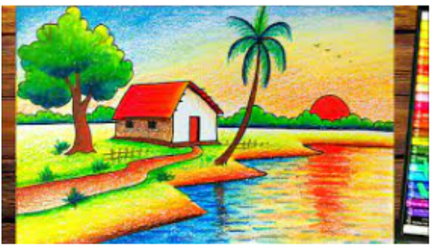

Output:
